ISSACK WAITHAKA
cs-sa07-24085

-The first thing was to start the machine

Installing Impackets
- The next step was to install impackets
- I installed bloodhound which is one of the tools we will be using in this room

Enumeration
- It starts with an nmap scan.

I ran an nmap scan on the machine and realized that netBIOS used port 139
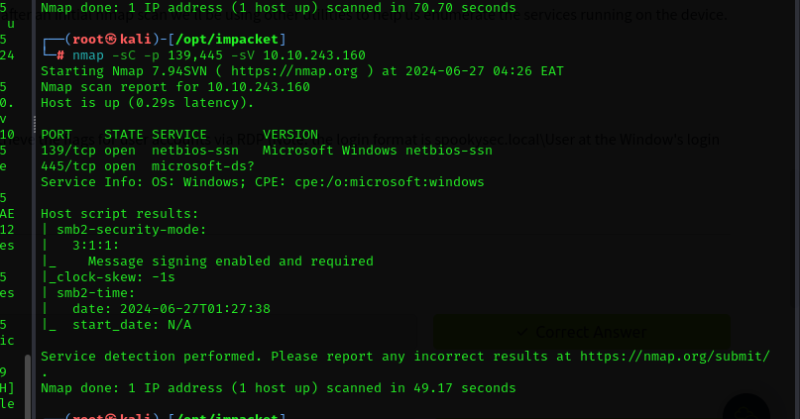
Questions
1.
=> since it used SMB protocol, enum4linux would be the best tool for enumerating information from Windows and Samba systems

2.
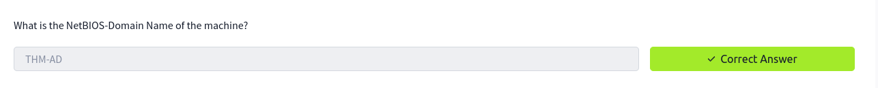
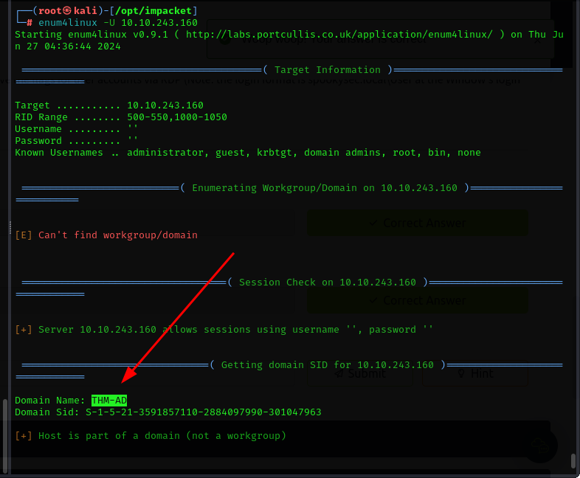
3.
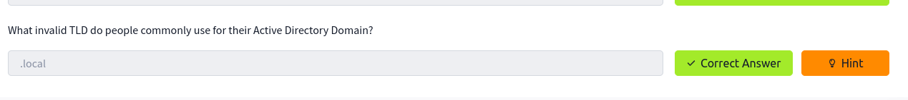

Enumerating Users via Kerberos
- Kerberos is an authentication service within Active Directory, Which can be brute forced for the discovery of usernames and passwords

Questions
1.
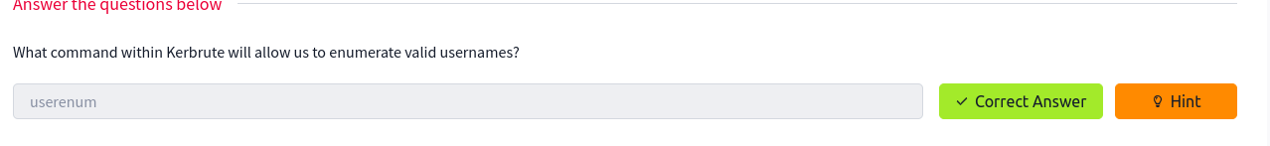
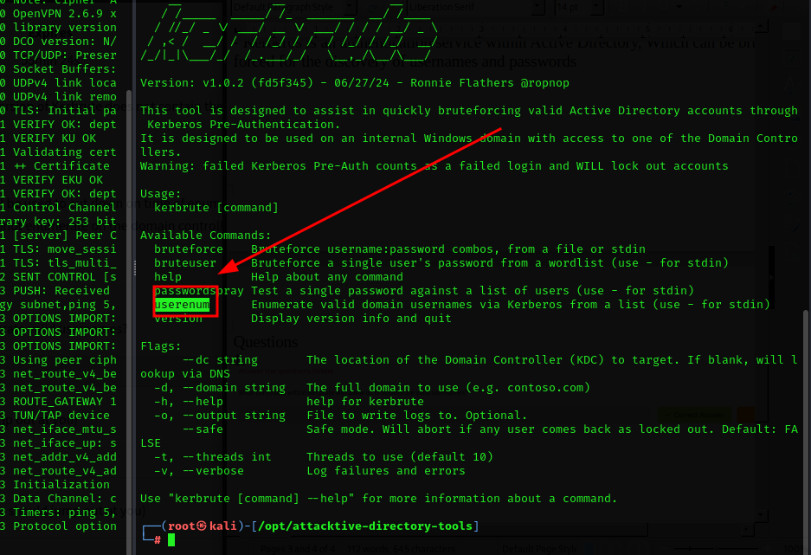
2.

3.
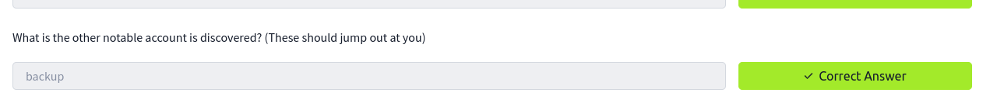
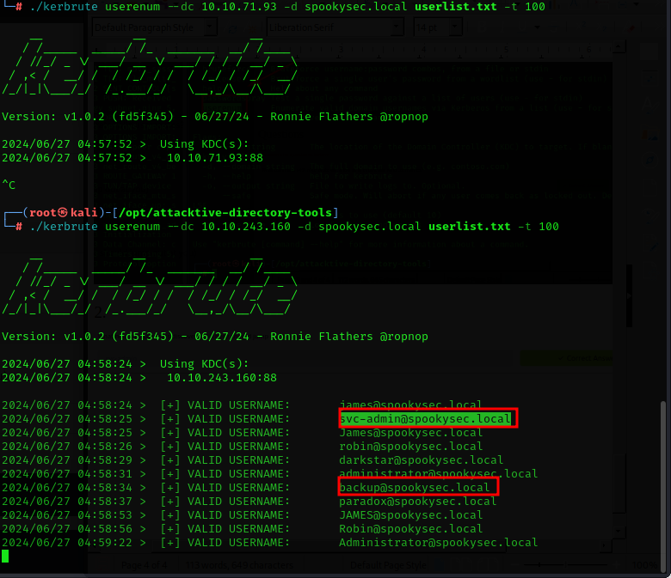

Abusing Kerberos
- We will use a method called ASREPRoasting which occurs when a user account do not require pre-authentication

Questions
1.
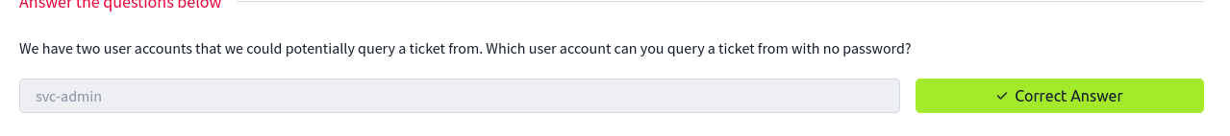

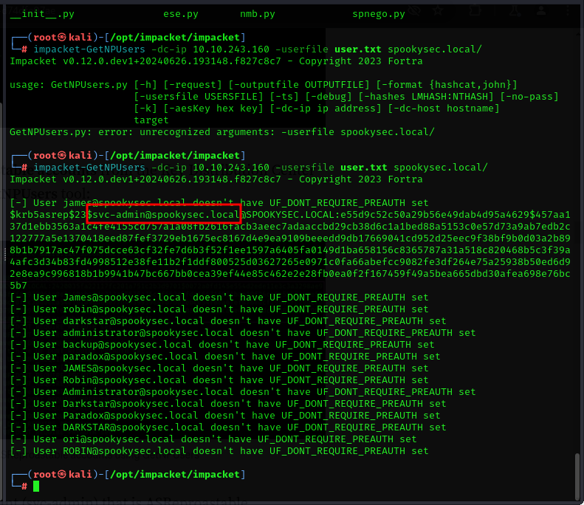
2.
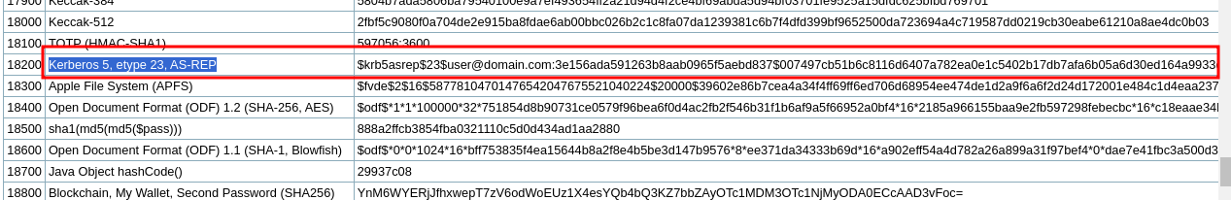
3.
4.
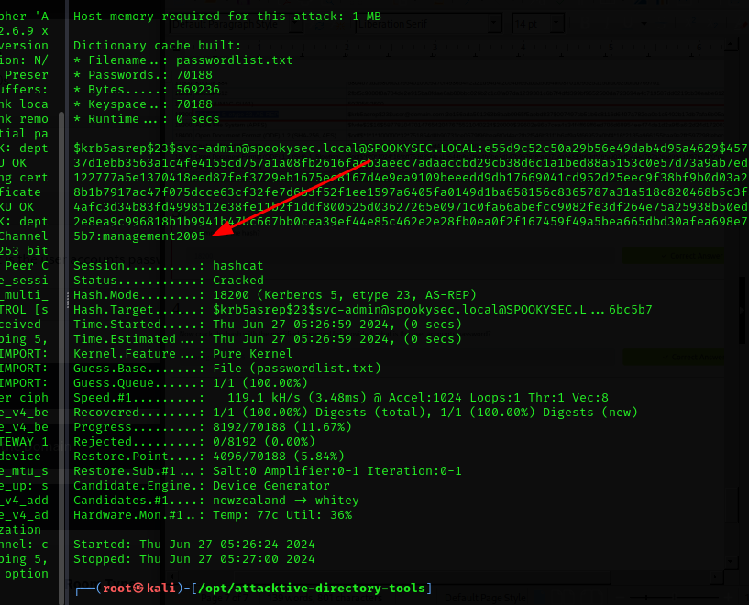
Enumeration

Questions
1.
2.

3.
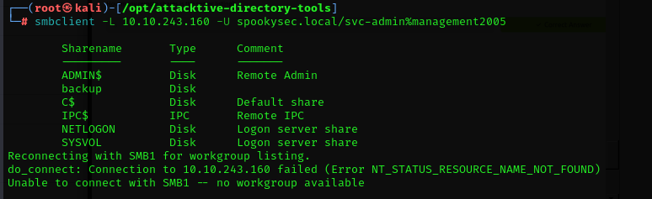
4.
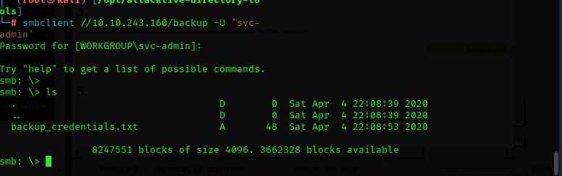
5.&6.
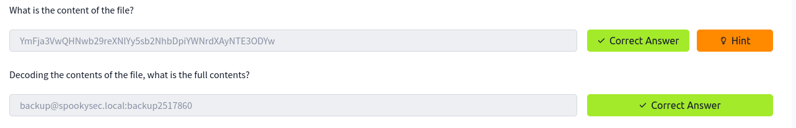

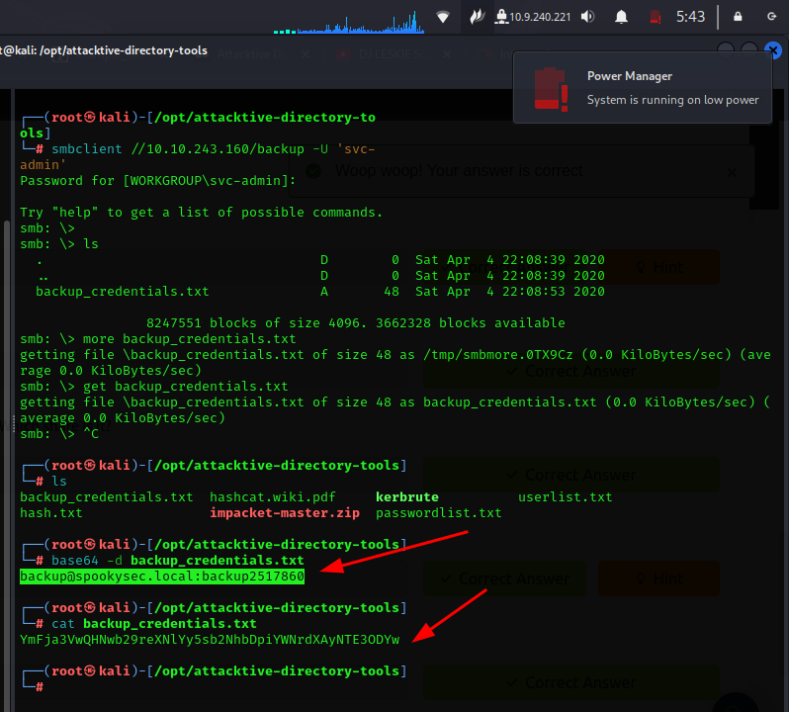

Elevating privileges

Questions
1.
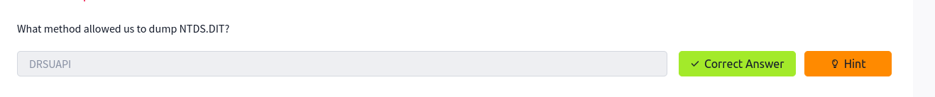
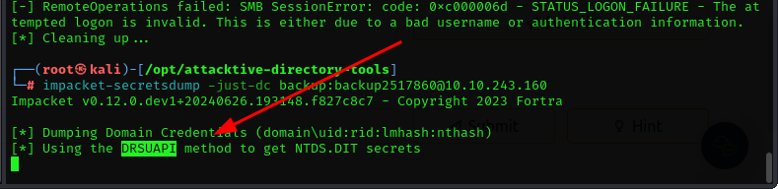
2.
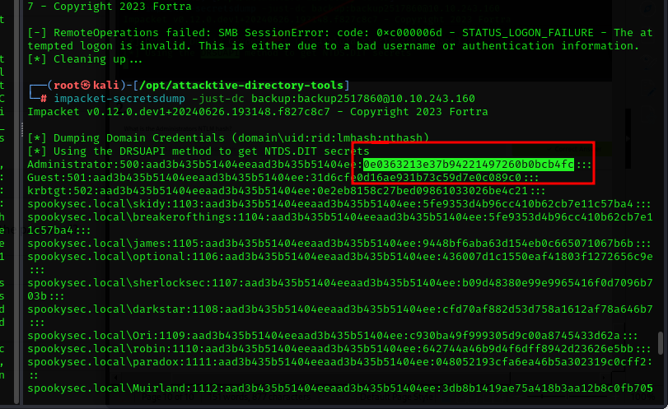
3.
4.
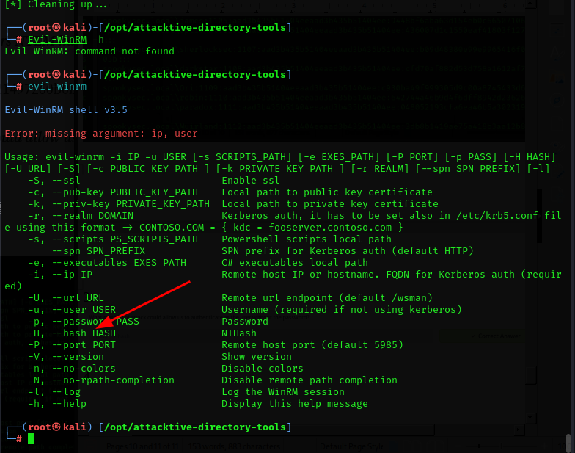

Flag submission
1.
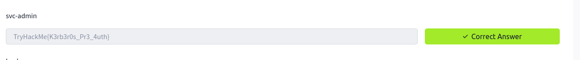
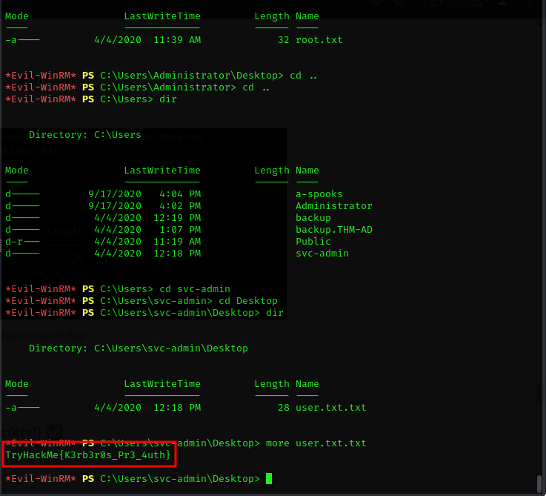
2.
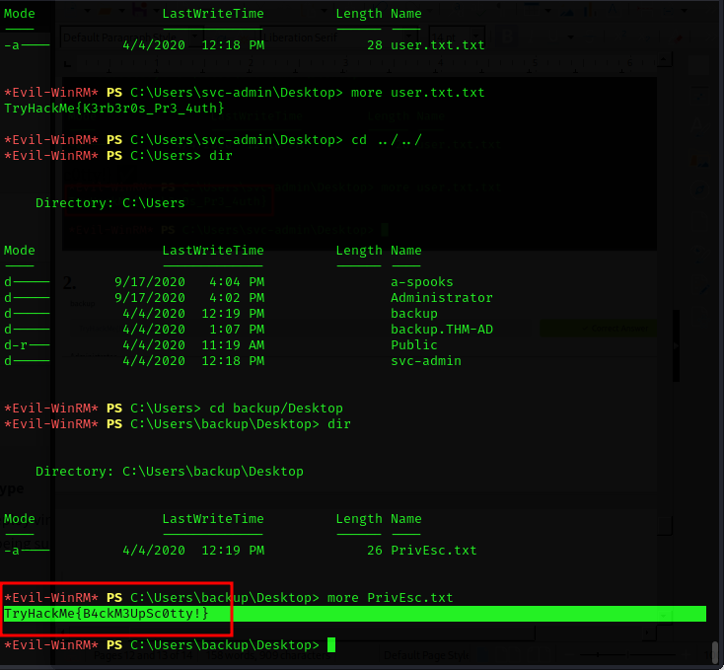

3.
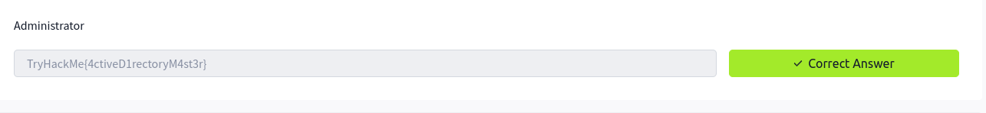
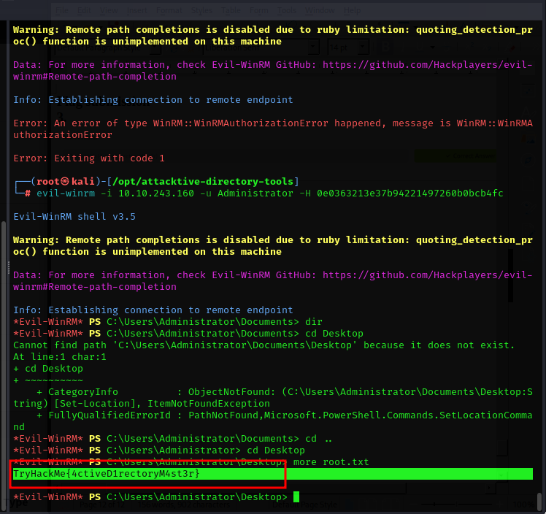

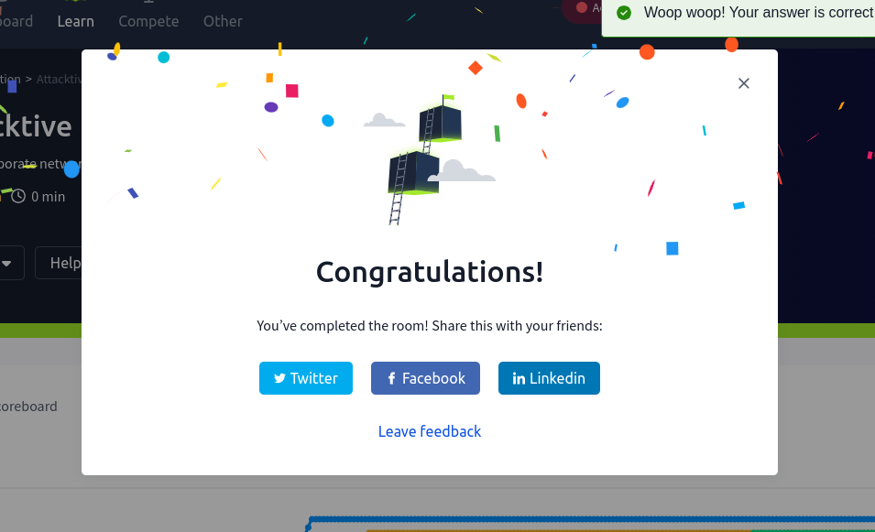

Conclusion
- This was a quite challenging room for me. But I am glad I was able to through it. I have learnt to some of the tools like kerbrute which are used in active directory attacks. I look forward to many other challenges.

